SVN Client Installation
This tutorial outlines two Subversion clients namely, TortoiseSVN and RapidSVN. The features for each client are listed below.

TortoiseSVN:
Features
- All commands are available directly from the windows explorer.
- Only commands that make sense for the selected file/folder are shown. You won't see any commands that you can't use in your situation.
- See the status of your files directly in the Windows explorer
- Descriptive dialogs, constantly improved due to user feedback
- Allows moving files by right-dragging them in the windows explorer

However TortoiseSVN is available only for Windows operating system.

RapidSVN:
Features
- Simple - provides an easy to use interface for Subversion features
- Efficient - simple for beginners but flexible enough to increase productivity for experienced Subversion users
- Portable - runs on any platform on which Subversion and wxWidgets can run: Linux, Windows, Mac OS/X, Solaris, etc.
- Fast - entirely written in C++

The GUI is simple and does not integrate with Windows Explorer.

However, both Subversion Clients offer the same functionality and hence users can choose the client which suits there needs.

Tortoise SVN

Download url: http://tortoisesvn.net/downloads/ (or)
http://sourceforge.net/project/showfiles.php?group_id=138498&package_id=151948

Download file name: TortoiseSVN-1.4.0.7195-RC1-win32-svn-1.4.0RC1.msi
Follow the screen shots to complete the installation.

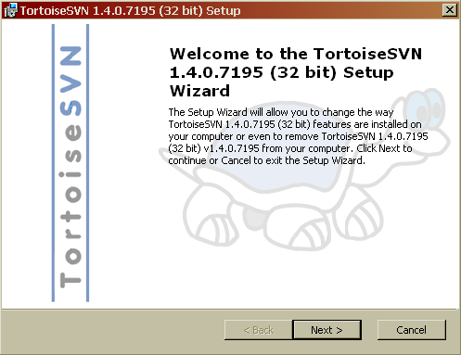

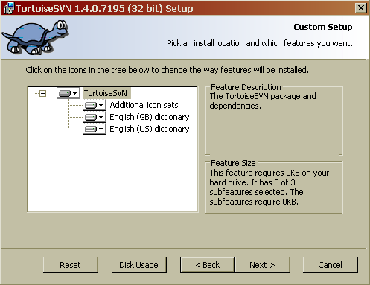

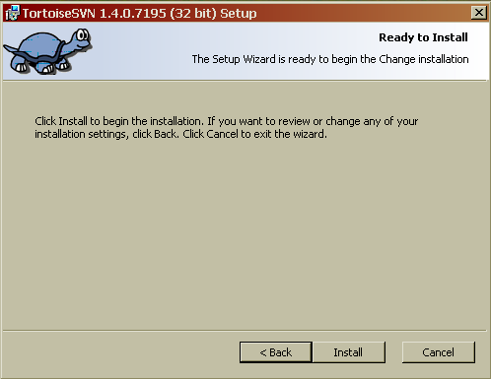

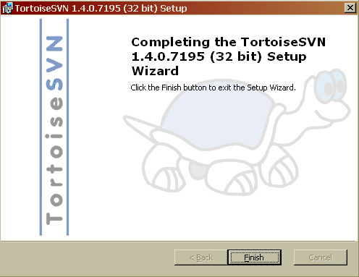

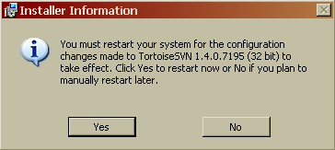

Basic Operations
Checkout

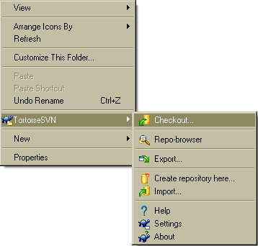

To check out from the svn server, create a new directory. The right click option should provide the menu shown in the above figure, with checkout being the first option. The checkout url is
svn://138.37.35.159:3690/opt/webroot/kspace/svn

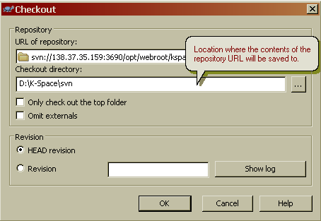

In the revision section, HEAD revision refers to the working copy and hence it is recommended to checkout the HEAD revision for the first time. However, for previous version, use the “Show log” option and the specific revision number to check out the specific revision.

Authentication
SVN server requires authentication before any operation can be performed like check out, update, add, delete, commit etc. The server is configured with three level access controls, in which no authenticated user can access the server; authenticated users with K-Space will be able to perform “Checkout” and “Update” operations.

The username and password for each partner will be sent via separate email.

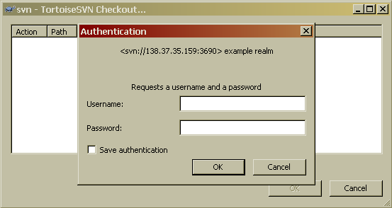

Using the user name and password, you can checkout the initial module as shown below.

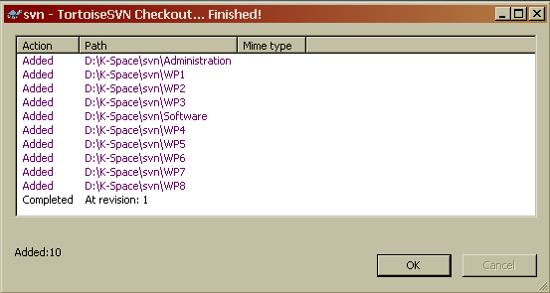

Successful checkout should produce the directory structure as above and the files from the server would be available. The icons inside the checkout directory should be as shown below.

Update
For update and commit operations, use the option SVN Update and SVN Commit respectively.

The menu options shown below can be accessed by right clicking on the folder to be updated (Note: This will update all the subfolders as well).

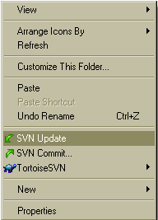

Rapid SVN

Download url: http://rapidsvn.tigris.org/

To download the file, click on the following links:

Download RapidSVN 0.9.3 Source Code
Download RapidSVN 0.9.3-1 for Windows
Download RapidSVN 0.9.3 for Mac OS/X
Download RapidSVN for Linux

Download file name: RapidSVN-0.9.3-1.exe (Windows)
Follow the screen shots to complete the installation

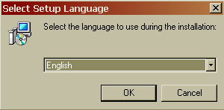

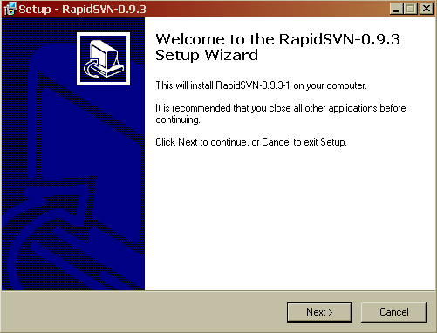

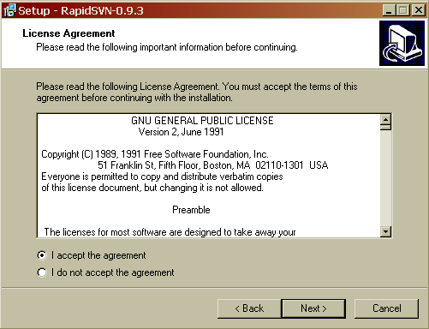

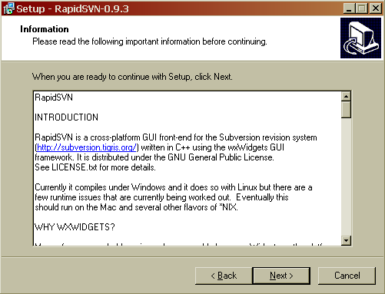

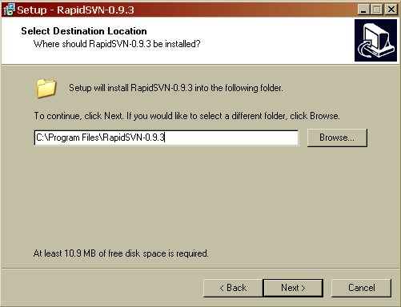
Default Installation Directory

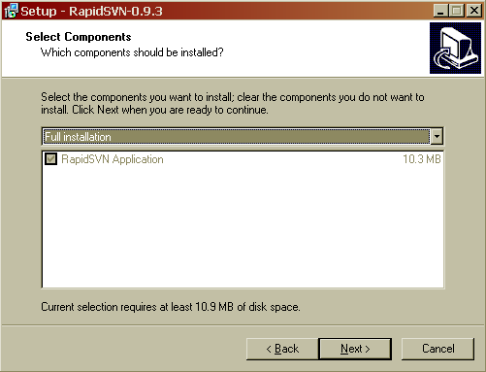

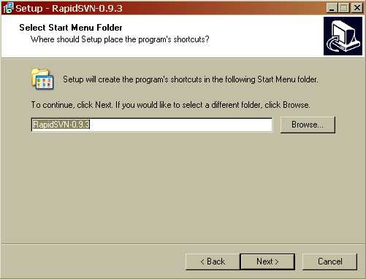

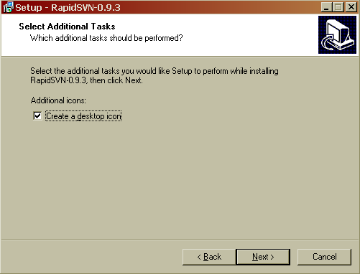

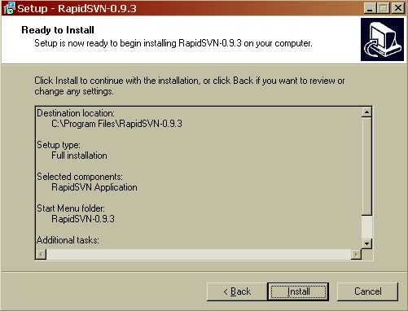

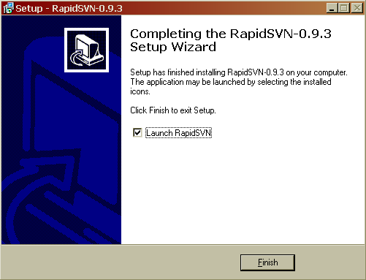

Once installed, there will be new shortcut added to the program menu (if you have selected). The first time, the RapidSVN is launched; the following application window opens up.
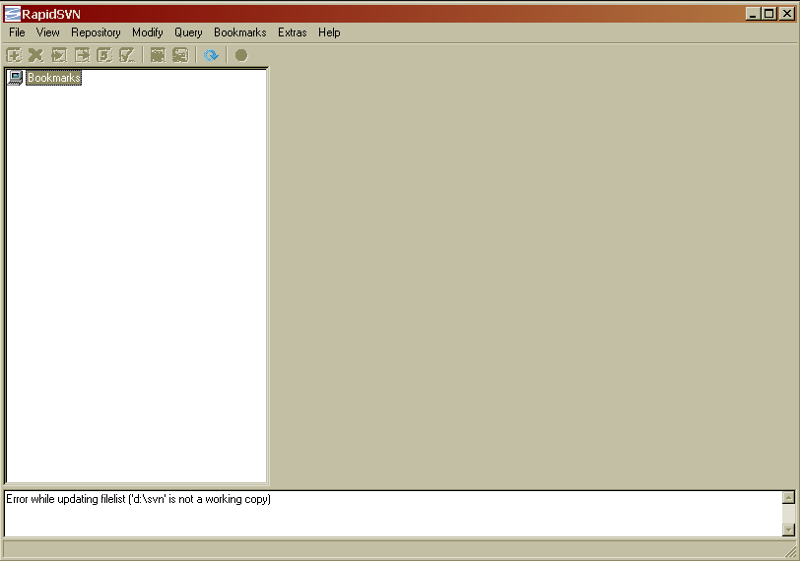

Basic Operations:
Checkout:
To checkout the working copy from the repository follow the steps below.

Repository -> Checkout (CTRL+O)

In the checkout url, type:

svn://138.37.35.159:3690/opt/webroot/kspace/svn

The destination directory is the local directory, where the repository will be created.

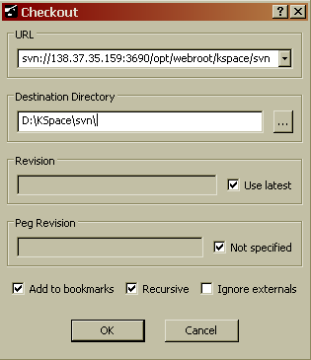

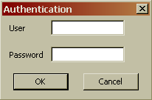

Entering the username and password, should successfully complete the “Checkout” operation and the check out location will be as shown below.

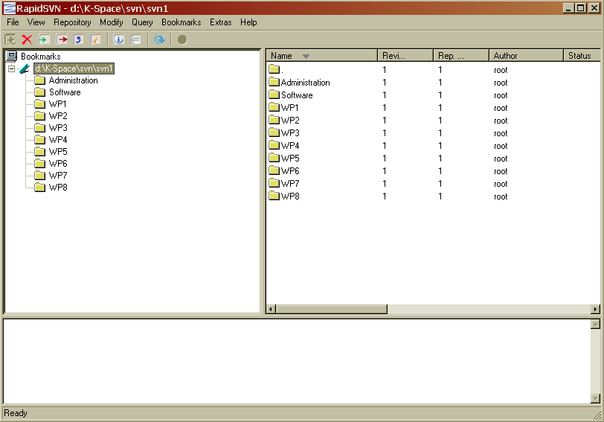

After the repository is successfully checked out, the bookmark should indicate the location and the contents of the repository.

Update:
For update and commit changes, use the menu option

Modify -> update

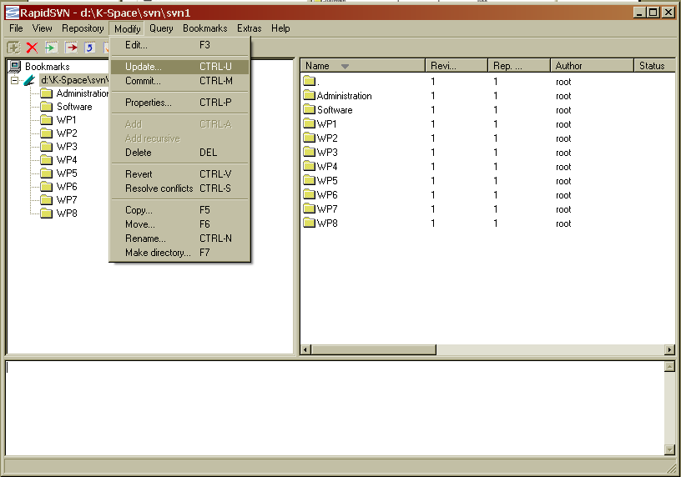

Or right click on the directory or file to be updated, as shown in the following screen shot.

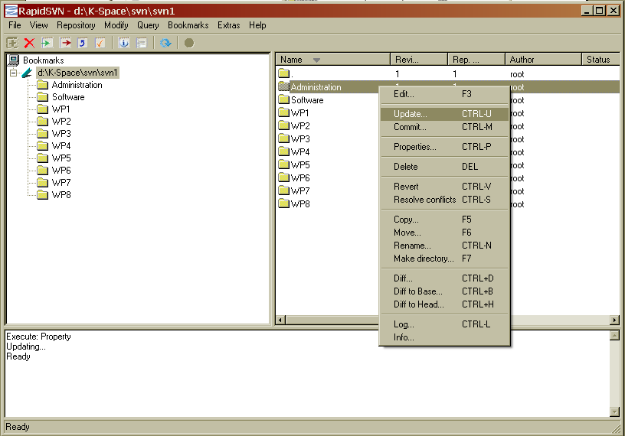

Note: The screen shots provided for are from Windows based system and hence the screen shots for other operating system might vary.

Contact:
For additional queries please contact:
Craig Stewart: craig.stewart@elec.qmul.ac.uk

